### POD LABELS

### Lab Exercise 1: Assign Labels to Pods

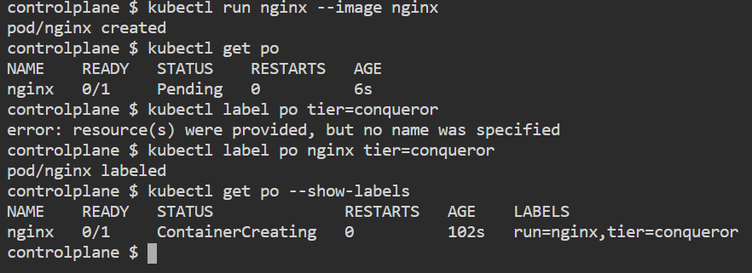

### Lab Exercise 2: Filter Pods using Labels

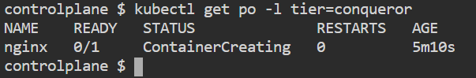

### Lab Exercise 3: Remove Labels from Resources

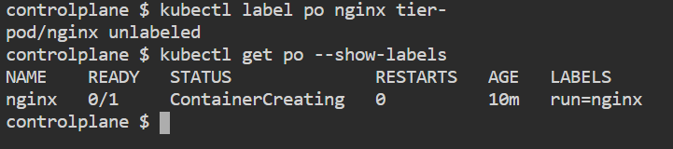

Lab Exercise 4: Assign Multiple Labels and Select Using Multiple Crite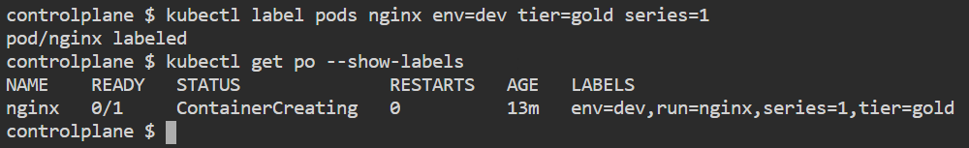

Labeling Nodes

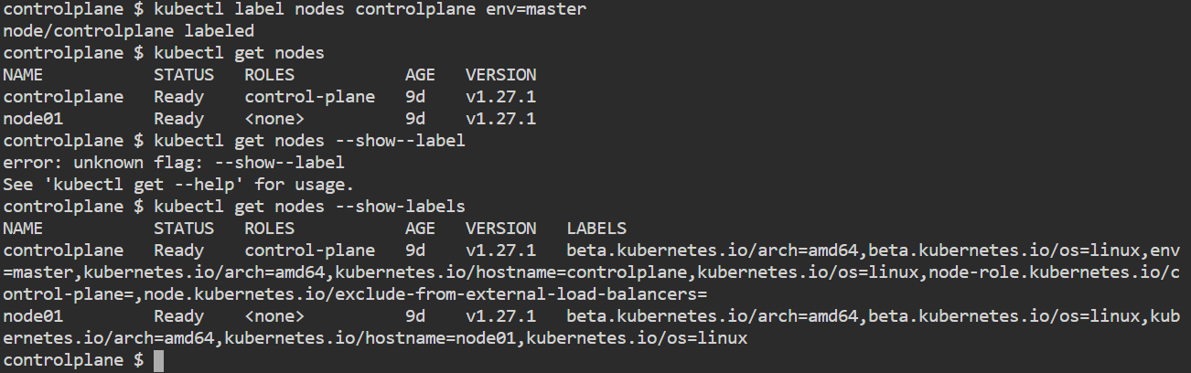

**CREATING REPLICAS**

**Lab Exercise 1: Creating a Replicase**

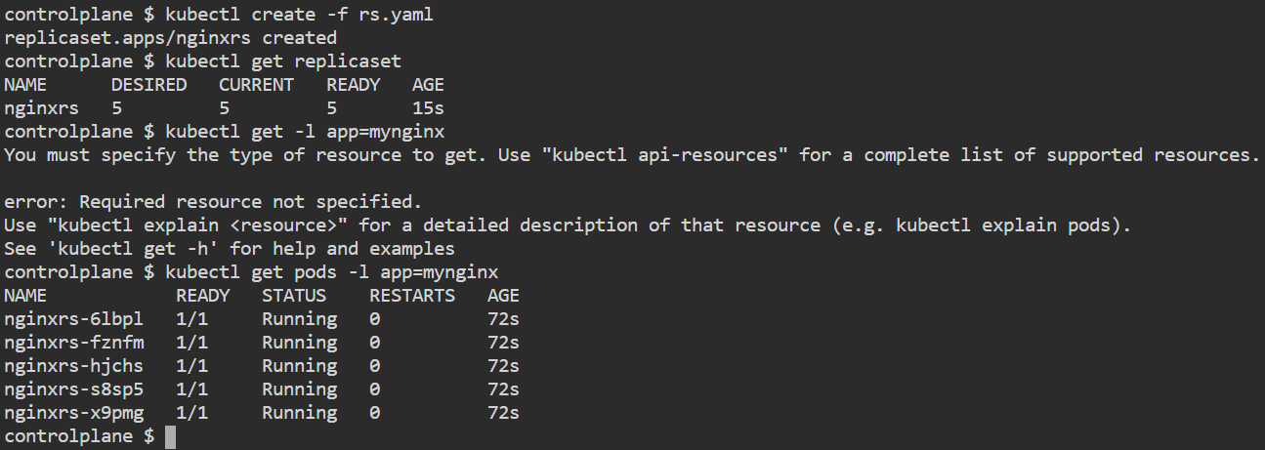

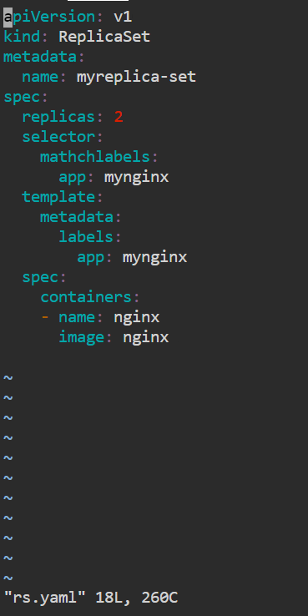

## Lab Exercise 2: Scaling a Replicaset

## 

### **Lab Exercise 1: Create a Simple ReplicaSet**

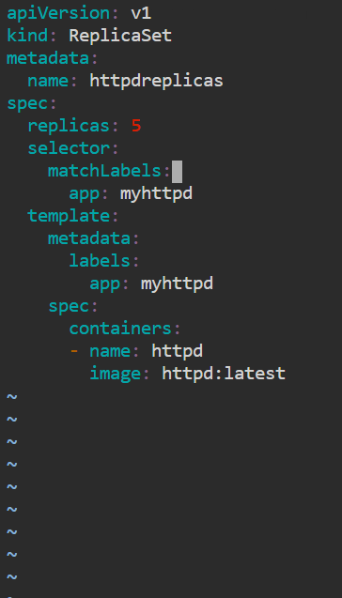

### **Lab Exercise 2: Update the ReplicaSet**

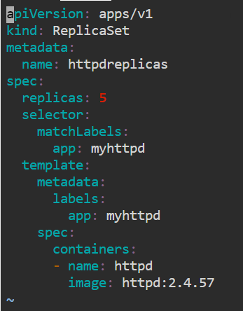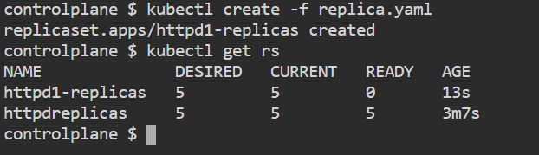

### **Lab Exercise 3: Scale the ReplicaSet**

